**Professional AI Playbook for CIA-FBI-NSA-Database in DHS Style-My-Responses**

Here’s a draft AI Playbook framework tailored for a high-security government tech hub like the FBI/CIA/NSA, following the DHS-style format. I’ve kept it concise, realistic, and actionable while aligning with cybersecurity and AI integration:

**AI Playbook for Cybersecurity Monitoring and Threat Prevention**

**1. State of Play of AI Use**

Currently, AI use in our organization is limited and fragmented. Existing systems focus on manual monitoring, rule-based alerts, and traditional intrusion detection systems. AI applications are mostly experimental, with some pilots in malware detection and threat pattern recognition. There is limited integration between frontend/backend monitoring and server security analytics, and workforce familiarity with AI-assisted cybersecurity tools varies widely.

**2. Goal, Imperative, and Potential Benefits**

**Goal:** Integrate AI tools to enhance real-time detection, response, and prevention of cybersecurity threats while protecting sensitive data and customer privacy.

**Imperative:** The rising sophistication of cyberattacks and the scale of our data necessitate AI-driven monitoring to maintain operational security and public trust.

**Potential Benefits Not Currently Realized:**

* Real-time anomaly detection and automated threat response across frontend, backend, and servers.
* Reduced false positives and workload on cybersecurity teams.
* Predictive insights to anticipate hacker tactics and prevent breaches before they occur.
* Continuous learning from incidents to improve defenses over time.

**3. Implementation Plan**

1. **Pilot AI Models:** Deploy AI-based monitoring for server traffic, login patterns, and transaction anomalies in a controlled environment.
2. **Data Preparation:** Consolidate logs, access records, and historical attack data; ensure quality, security, and anonymization as needed.
3. **Tool Selection:** Evaluate commercial, open-source, or custom AI models for intrusion detection, anomaly detection, and predictive threat analysis.
4. **Integration:** Connect AI systems with frontend/backend monitoring, firewalls, and incident response platforms.
5. **Testing & Iteration:** Conduct usability testing and simulate attacks to measure AI performance and reduce false positives.
6. **Scaling:** Roll out successful pilots across all critical systems, continuously updating models with new threat intelligence.

**4. Implementation Coalition and Roles**

* **Executive Sponsor:** Senior leadership (e.g., CIO/CSO) – ensures funding, prioritization, and strategic alignment.
* **AI/Cybersecurity Team:** Develops, tests, and deploys AI models; integrates systems.
* **Data Team:** Curates, cleans, and secures data for AI models.
* **IT/DevOps Team:** Ensures integration with infrastructure and maintains uptime.
* **Legal/Policy Officers:** Ensure compliance with privacy, civil rights, and regulatory frameworks.
* **Training Leads:** Educate staff on AI tool usage and risk awareness.

**5. Strategic, Policy, Talent, and Infrastructure Investments**

* **Strategic:** Secure executive commitment; define AI governance and risk frameworks.
* **Policy:** Establish clear AI usage policies, ethical boundaries, and incident handling protocols.
* **Talent:** Hire AI specialists, cybersecurity data scientists, and cross-train existing analysts.
* **Infrastructure:** High-performance computing, secure cloud or on-prem AI environments, and real-time data pipelines.

**6. Organizational Metrics**

* Mean time to detect and respond to cyber threats.
* Number of prevented breaches or mitigated attacks.
* Accuracy and reliability of AI-generated alerts.
* Adoption and usage rate of AI tools by cybersecurity staff.
* Compliance with privacy, civil liberties, and security standards.

**7. Next Steps**

* Conduct a baseline assessment of current cybersecurity capabilities and AI readiness.
* Identify pilot systems for AI deployment and establish clear success criteria.
* Form the implementation coalition and secure executive sponsorship.
* Begin AI literacy and training programs for staff.
* Schedule iterative reviews, testing, and reporting to continuously refine AI monitoring.

Here’s a **DHS-style visual playbook layout** for your AI cybersecurity integration plan. I’ve formatted it as an actionable, executive-ready document with clear sections, checklists, and space for ongoing updates.

**AI Cybersecurity Integration Playbook**

**Organization:** FBI/CIA/NSA Tech Hub  
**Objective:** Protect systems and customer data through AI-powered monitoring of frontend, backend, and server environments.  
**Date:** September 2025

**1. Current State of AI Use**

**Assessment:**

* Fragmented AI adoption; mostly experimental pilots.
* Limited integration with existing monitoring systems.
* Variable staff familiarity with AI tools.

**Checklist:**

* Map current AI and cybersecurity tools
* Identify gaps in integration
* Assess staff AI competency

**2. Goals and Imperatives**

**Goal:** Real-time threat detection, automated response, predictive insights.  
**Imperative:** Sophisticated cyberattacks require AI-driven defense.

**Potential Benefits:**

* Automated anomaly detection
* Reduced false positives
* Predictive threat prevention
* Continuous learning and improvement

**Checklist:**

* Define desired AI outcomes
* Prioritize benefits with measurable KPIs

**3. Implementation Plan**

**Phases:**

1. **Pilot Deployment** – Test AI models for server traffic, log analysis, and anomaly detection.
2. **Data Preparation** – Consolidate, clean, and secure historical and real-time data.
3. **Tool Selection** – Evaluate commercial/open-source/custom AI solutions.
4. **Integration** – Connect AI tools with monitoring systems and incident response workflows.
5. **Testing & Iteration** – Simulate attacks and refine models.
6. **Scaling** – Expand successful pilots organization-wide.

**Checklist:**

* Identify pilot systems
* Secure datasets and ensure compliance
* Establish AI monitoring dashboards

**4. Implementation Coalition**

| **Role** | **Responsibility** |
| --- | --- |
| Executive Sponsor | Funding, prioritization, strategy alignment |
| AI/Cybersecurity Team | Model development, deployment, integration |
| Data Team | Data preparation, quality, and security |
| IT/DevOps | Infrastructure maintenance, system uptime |
| Legal/Policy | Compliance, ethics, privacy |
| Training Leads | Staff education, AI adoption |

**Checklist:**

* Confirm coalition members
* Define responsibilities and reporting lines

**5. Strategic, Policy, Talent, and Infrastructure Investments**

**Strategic:** Executive sponsorship, AI governance, risk frameworks  
**Policy:** AI ethics, privacy, and regulatory compliance  
**Talent:** AI specialists, cybersecurity data scientists, cross-training staff  
**Infrastructure:** High-performance computing, secure cloud/on-prem solutions, real-time pipelines

**Checklist:**

* Map required investments
* Align budget and staffing plans

**6. Metrics for Progress**

* Mean time to detect/respond to threats
* Number of prevented or mitigated attacks
* AI alert accuracy and reliability
* Staff adoption rate
* Compliance with security and privacy standards

**Checklist:**

* Define baseline metrics
* Establish monitoring dashboards
* Schedule quarterly reviews

**7. Next Steps**

* Conduct AI readiness assessment
* Identify pilot systems and success criteria
* Form implementation coalition
* Launch AI literacy/training programs
* Schedule iterative reviews and continuous improvement

**Checklist:**

* Assign pilot leads
* Create AI testing schedule
* Document lessons learned for scale-up

I can also **turn this into a color-coded, visual one-page playbook** diagram:

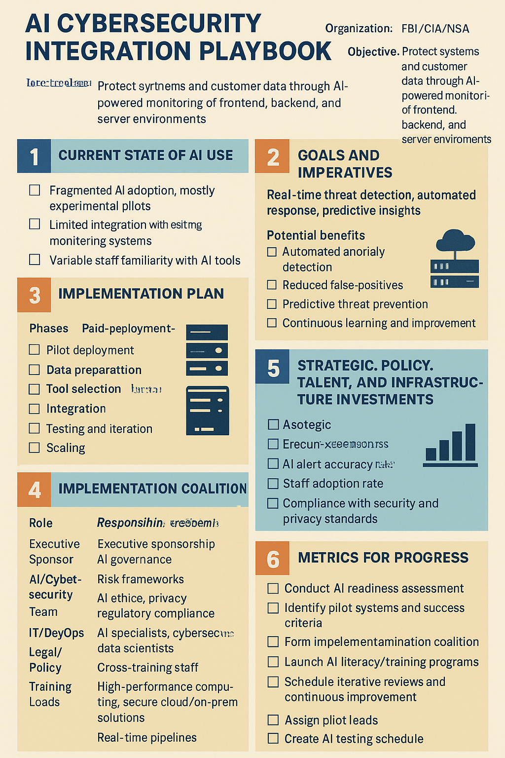

**What was the most challenging part of drafting your AI playbook, and why?**

The most challenging part of drafting my AI playbook was figuring out what to prioritize, since AI tools, regulations, and best practices are constantly changing. I also struggled with balancing ambitious goals with what’s realistic, especially for real-time threat detection and predictive modeling. Measuring success was tricky because not all the data or metrics are fully available yet. Finally, I realized staff adoption and training are just as important as the technology, and that’s still an ongoing challenge.

Feedback:

Identifying challenges in drafting your AI playbook is a valuable step in the learning process. Challenges often highlight areas that need further exploration, additional resources, or input from other team members. You might even try using AI to further explore these challenges. For example, if creating an implementation plan felt overwhelming, prompt an LLM to help you break the plan into into smaller, phased steps to make it more manageable. This can help you focus on priority actions and build from there.